**Lab: Automated Defense and Pretense against Distributed Denial of Service Attacks**

*Dr. Prasad Calyam (Contact:* [*calyamp@missouri.edu*](mailto:calyamp@missouri.edu)*)*

Compiled by Ramya Payyavula

1. **Purpose of the Lab**

To create a cloud infrastructure that hosts a web server on GENI cloud testbed, faking a DDoS attack on the virtual machine hosting the service to make the service unavailable. Detecting a DDoS attack and applying pretense methodology on the attacker, resulting in a smooth traffic to the actual virtual machine hosting web server. Understanding how lack of adequate defense strategies can affect a cloud service provider in LoA. Learning various tools like Frenetic, Mininet, Scapy and OvSwitch.

Compared to the previous MTD lab, in this exercise you will learn more about how to setup network policies for monitoring attacks, blacklisting attacker flows, and applying a defense using pretense via Scapy. You will also realize how to analyze network flows at root switch to understand the attack has no impact on the target application.

1. **References to guide Lab Work**

* **OCaml Package Manager**

https://opam.ocaml.org/

* **Frenetic Network Programming**

<https://github.com/frenetic-lang/manual/blob/master/programmers_guide/frenetic_programmers_guide.pdf>

* **OvS Open vSwitch**

<http://docs.openvswitch.org/en/latest/faq/openflow/>

* **Scapy**

<https://scapy.net/>

* **Critical Reading**

1.<http://citeseerx.ist.psu.edu/viewdoc/download?doi=10.1.1.703.2913&rep=rep1&type=pdf>

2. <https://ieeexplore.ieee.org/abstract/document/6883418>

3. <https://www.bostonglobe.com/business/2016/10/21/yes-your-internet-has-probably-been-less-than-perfect-today/kISaYiya1qsNw9kkvEakrJ/story.html>

4. <https://techcrunch.com/2016/10/21/many-sites-including-twitter-and-spotify-suffering-outage>

5. <https://www.calyptix.com/top-threats/ddos-attacks-2018-new-records-and-trends/>

6. <https://www.cs.princeton.edu/~jrex/papers/icfp11.pdf>

7. <https://www.digitalocean.com/community/tutorials/how-to-migrate-a-mysql-database-to-a-new-server-on-ubuntu-14-04>

1. **Lab steps and output collection guidelines**

To complete this Lab, you will need to perform the following steps:

In the first step, you will setup the testbed required for the experiment, then install the controller, root switch and slave switch. After this, you will install a LAMP stack, Dolus project (suspicious scores scripts, logs, attacker and quarantine machine scripts) and frenetic. You will also setup default routing between the root switch and slave switch and capture the packets flowing between the machines. Then, using network Policies, detect an attacker and move the attacker flow to the quarantine machine to deceive the attacker. You can observe the network flow and all the other information regarding the server, users, devices, attacker and quarantine machines on the public routable IP of the controller.

**Note: Don’t miss any step in the installation process, If you miss that you might not be able to access AdminUI. Keep you slice and resource reserved for the whole semester as you can use the same slice and resources for other 2 labs**

* 1. **Setup a slice with a controller, root-switch, slave-switch, quarantine machine, user and an attacker.**

1. Login to GENI portal and create a slice or load an existing empty slice for the lab. We are going to reserve the resources using Graphical Interface of the portal (Jacks). Reserve your controller device in a separate slice by itself. That way if there is a failure on another aggregate, you can delete that slice and try again without losing all your setup on the controller.

### Load a simple topology in Jacks

|  |
| --- |
| 1. In the Portal, open the Slice page for the slice you just created (Click on slices, select project and add name to the slice). Notice that you can create the slice with omni or Jacks. 2. Press the **Add Resources** button to launch Jacks for this slice. 3. From the **Choose Rspec** menu, select ‘Files’ option to load the provided Rspec file for Controller and other aggregates in respective slices. 4. Once it is done, a few VMs, a root-switch, a slave-switch, users and attackers appear in one slice. And a controller appears in the controller slice. 5. Choose an aggregate to select where to reserve the resources and then click on “Reserve resources”. |

The topology you loaded has three VM types and a switch:

* 1. Server
  2. Controller
  3. Attacker
  4. User

The sliver should look something like this:

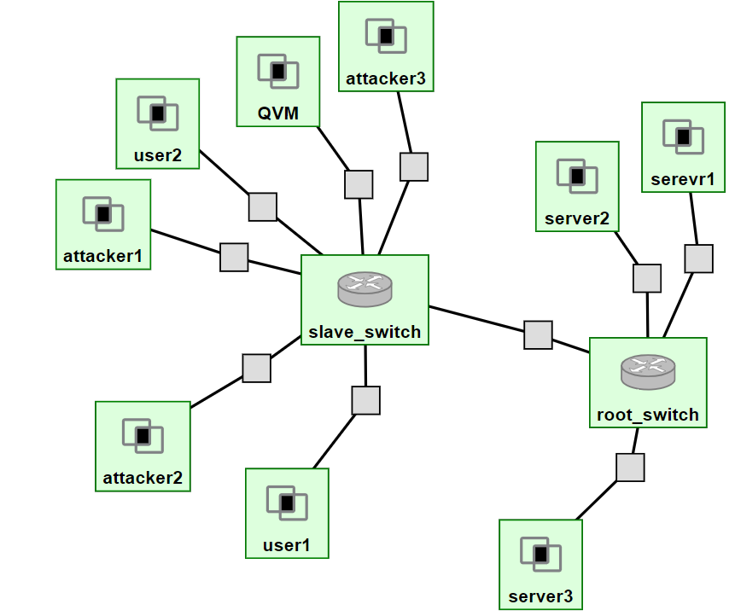

The controller sliver should look something like this:

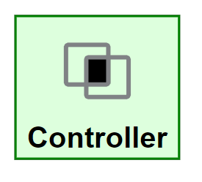

* 1. **Controller Installation**

The controller is used to capture the network traffic and packet flow on the root-switch and slave-switch, calculate the suspiciousness scores, and detect an attacker. To configure the controller, please execute the following commands below to download and execute the controller installation script:

**Follow steps in the manual sequentially unless it’s mentioned to do simultaneously.**

1. First, SSH into the controller using the GENI interface.
2. After you are logged in, please execute the following command to install curl, which will enable you to download the configuration script:

|  |
| --- |
| *sudo apt-get update && sudo apt-get -y install curl && sudo apt-get -y install vim* |

1. After installing curl, please run the following command to download the script.

|  |
| --- |
| *curl -LO https://gist.githubusercontent.com/wangso/52a30bf71bcb0252c4da3c54ce697e11/raw/d3ed25f29e9b6dbf129aa16911807a78ea5ba8a3/controller_install.sh* |

After downloading the script, please run the following command to make the script executable:

|  |
| --- |
| *chmod +x con\** |

1. Then, run the following command to execute the script. Please note: The script will take approximately one hour to complete, so please ensure that you set your computer to not fall asleep so that the script can execute. Alternatively, you can use the screen command to execute the script even if the SSH session disconnects. Please see the last page of the lab for more instructions on how to use the screen command.

|  |
| --- |
| *sudo ./controller_install.sh* |

1. After the script has completed, please run the following command to start Frenetic to track the DPID numbers of the root switch and slave switch:

|  |
| --- |
| *~/.opam/4.06.0/bin/frenetic http-controller --verbosity debug* |

1. Now that Frenetic has been started, keep the terminal up and running and move on to the root switch installation. **Please note that you must leave this terminal up and running during the root-switch and slave-switch installation so that you can record the DPID numbers of both switches.**
   1. **Root-switch Installation**

**To configure the root-switch, please follow the following commands:**

1. First, SSH into the root switch using the GENI interface.
2. After connecting to the root switch via SSH, execute the following commands to install curl:

|  |
| --- |
| *sudo apt-get update && sudo apt-get -y install curl && sudo apt-get -y install vim* |

1. After curl is installed on the root switch, please run the following command to download the script.

|  |
| --- |
| *curl -LO https://gist.githubusercontent.com/wangso/b3f2ac104e4c5bd4ecfbfb649135a47b/raw/faf55a0a501e65f9bfaed10ddfe3c3043deb254a/root_switch_install.sh* |

1. Then, run the following command to make the script executable:

|  |
| --- |
| *chmod +x root\** |

1. After ensuring that the script is executable, execute the script by running the following command, replacing $ip with the address of the controller.

|  |
| --- |
| *sudo ./root_switch_install.sh $ip* |

The IP address of the controller can be found in the GENI interface as shown in the screenshot below:  
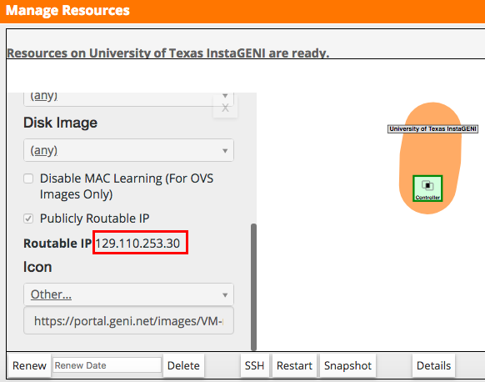

1. While the root switch configuration is running, be sure to keep the terminal open while the script executes and ensure that the SSH connection doesn’t disconnect. Upon completion of the script’s execution, please go back to the controller and take note of the DPID number that has been displayed in the Frenetic terminal interface. It is a number containing at least 14 digits that will be used to identify the root switch later.

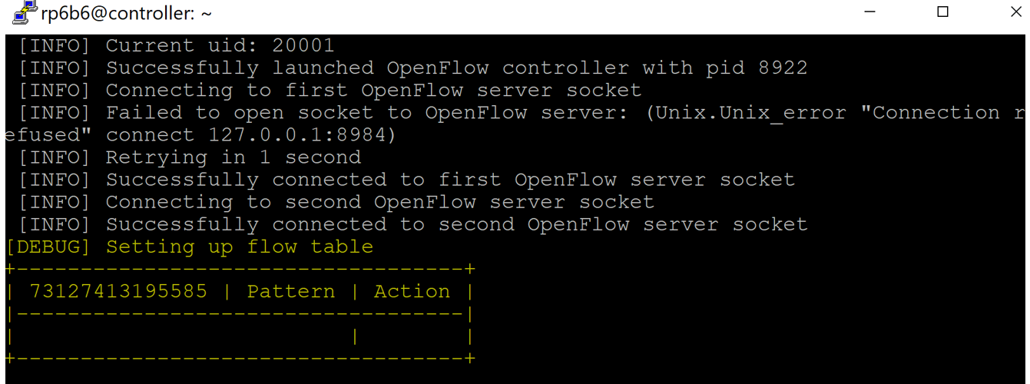

* 1. **Slave-switch Installation**

Each slave-switch installation may be slightly different depending on how many devices are connected to each.

1. First, SSH into the slave switch via the GENI interface.
2. After using SSH to connect to the slave switch, execute the following commands to install curl:

|  |
| --- |
| *sudo apt-get update && sudo apt-get -y install curl && sudo apt-get -y install vim* |

1. After the installation of curl is completed, please run the following command to download the slave switch installation and configuration script:

|  |
| --- |
| *curl -LO https://gist.githubusercontent.com/wangso/85a53d1787554f41f08ea15ae4bbe3bc/raw/59dc857a8ee50abed02ac729f833c49c746efbf4/slave_switch_install.sh* |

1. After the script has been downloaded, ensure the script is executable by running the following command:

|  |
| --- |
| *chmod +x slave_switch_install.sh* |

1. Now, execute the script by running the following command, replacing $ip with the IP address of the controller you used for the root switch installation script. Like the root switch installation and configuration script, this script will take much less time than the controller’s installation script.

|  |
| --- |
| *sudo ./slave_switch_install.sh $ip* |

1. After the script has been executed please go back to the open terminal instance connected to the controller and take note of the DPID number displayed. It is several at least 14 digits that will be used to identify the slave switch later as shown in the screenshot below:

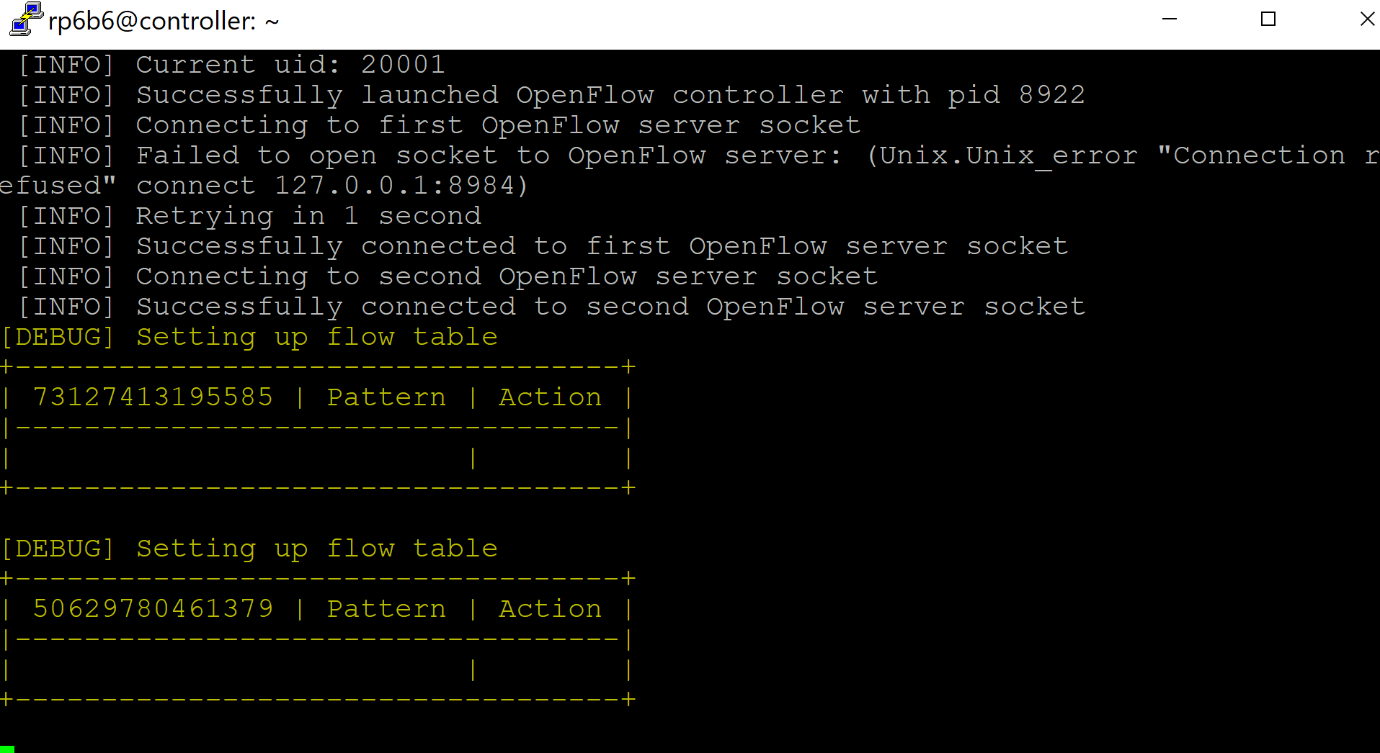

* 1. **Installing AdminUI on the controller**

AdminUI monitors the cloud network, keeps track of network components and network traffic. Policies generated by Frenetic can be updated using JSON arrays. Automatically blacklists the attacker once an attack is detected and updates the policies.

* 1. First, go back into the controller SSH instance that you’ve kept running. Make sure you’ve recorded the DPID numbers of both the root switch and slave switches, and then press Ctrl+C to quit the Frenetic process currently running.
  2. After the Frenetic process is no longer running, execute the following command to download the AdminUI installation and configuration script for the controller:

|  |
| --- |
| *curl -LO https://gist.githubusercontent.com/wangso/12b8d3e4abc5c823e6730d03c072f674/raw/27e980b436fff3434a0bc8040e754ec93e6831ad/controller_admin_ui_install.sh* |

* 1. After the script has been downloaded, execute the following command to make the script executable:

|  |
| --- |
| *chmod +x controller_admin_ui_install.sh* |

* 1. After the script is executable, run the following command to run the script to install and configure AdminUI on the controller. Make sure that you replace $rootDPID and $slaveDPID with the DPID numbers from the root switch and slave switch respectively:

|  |
| --- |
| *sudo ./controller_admin_ui_install.sh $rootDPID $slaveDPID* |

* 1. Once the script has completed, open your browser and input the IP address of the controller. You should be greeted with the Dolus welcome page as shown below:

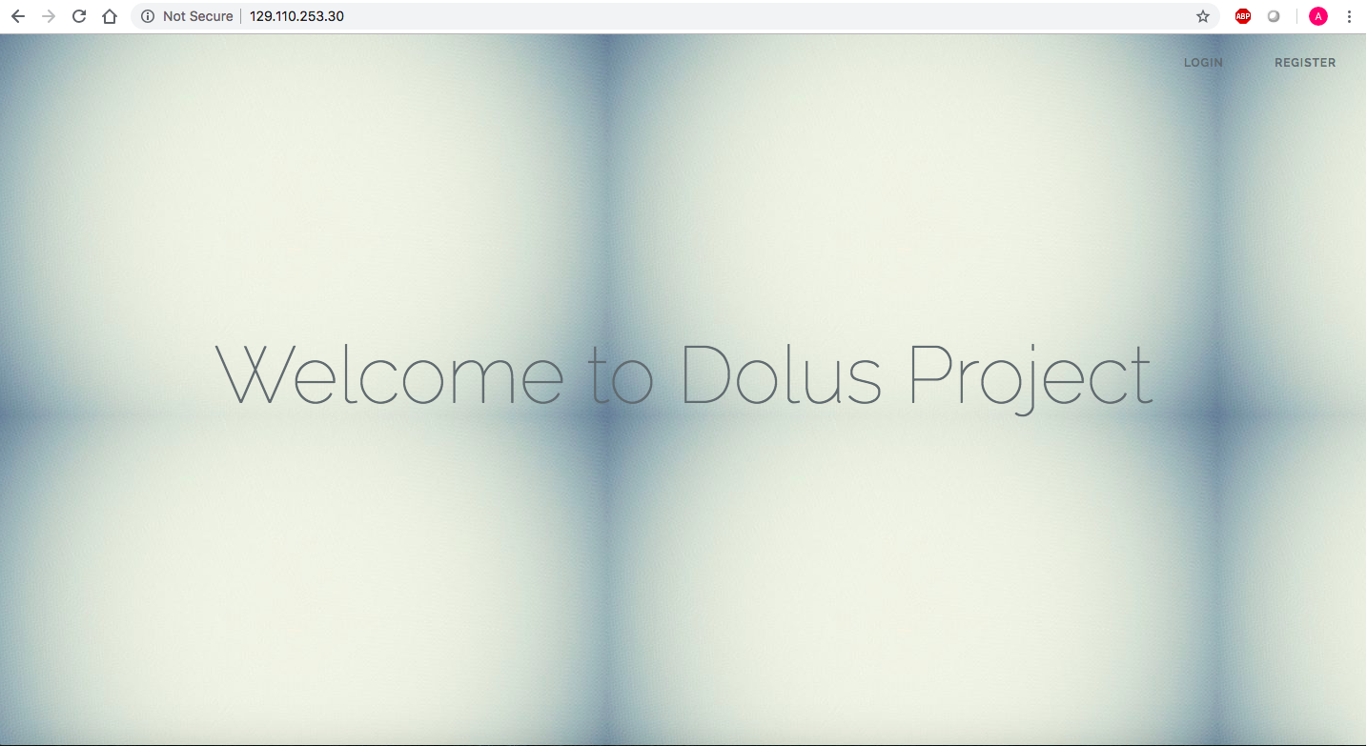

* 1. Click the Register option in the top right corner and register an account for the AdminUI. You can use any username or password that you want, but be sure to remember it, because you will need it to log in. Please note that your password must be at least 6 characters long.
  2. After registering, you will be taken to the login page. Please enter the credentials you entered to register with the site, and you will be taken to the Dolus webpage.

**Don’t panic some graphs will be empty as there is no network data flows happened till now.**

* 1. **Run Frenetic and setup default routing**

After ensuring that the webpage is up and running, we’ll need to run Frenetic again and set up default routing. Please use the following commands to start up Frenetic again:

|  |
| --- |
| *eval `opam config env` frenetic http-controller --verbosity debug* |

Once frenetic has been started, blank OpenFlow tables should be displayed in the console.

Since routing has not been configured yet, we’re going to take care of it now. To do so, log into the root-switch and run the ifconfig command. You will notice that there are 5 ethernet interfaces and one loopback interface. To configure the routing, we’ll need to match the MAC address to the settings contained in the openNetwork-ADAPTS.py file on the controller. Connect to the controller via SSH and execute the command cd /var/www/public_html/Dolus_DDos/app/Python/ to navigate to the directory containing the file we’re going to edit.

Now that we’re in the directory, execute the command nano openNetwork-ADAPTS.py to open the file (You’re welcome to use vim if you feel more comfortable with it, but I chose nano because the commands are at the bottom of the screen in the text editor). Using the arrow keys, navigate down to the first instance of root_switch. It should be on line 23, and the DPID number is being assigned to it. Change the DPID number in there to the DPID number of the root-switch that you recorded earlier, then find the slave_switch_1 variable. It should be on line 43, and also has a DPID number assigned to it. Change this DPID number to the slave-switch's DPID number as well. After changing the DPID numbers, we’re going to want to change the port numbers specified in the file. To do this, we’ll make a note of each connection’s IP and MAC address, then go on the switch and grep for it, finding the corresponding interface number. Once we do that, we’ll change the interface number for each server in the openNetwork-ADAPTS.py file to the one that matches it’s hardware ID. This portion is a bit complicated, but using the steps below, you will be able to correctly configure the system:

1. Change you root switch DPID in openNetwork-ADAPTS.py file like below

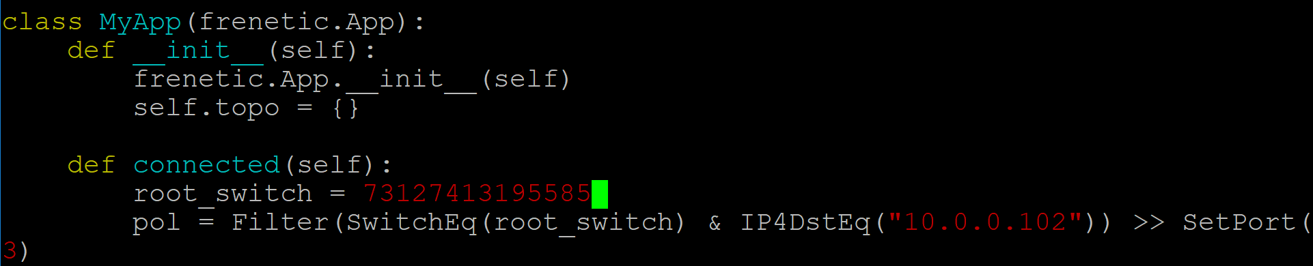

z

1. And slave switch DPID in openNetwork-ADAPTS.py file like below 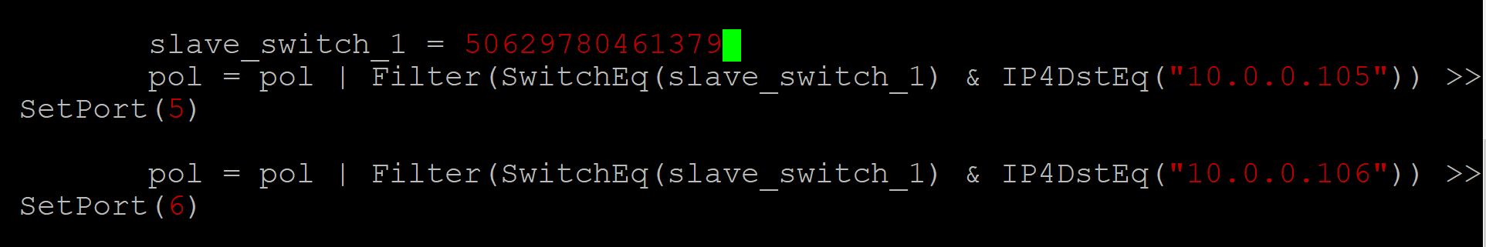
2. First, go to the GENI interface and click on the link between the root-switch and server3 as shown in the image below on the right side with a red box around it. This will open a tab on the left that will display the IP address and the MAC address of the interfaces connecting the root-switch and server3. Scroll down to the interface labeled Interface to root switch and make a note of the IP address and MAC address. For your convenience, the image below on the left hand side shows an example of where they are located on the page:  
   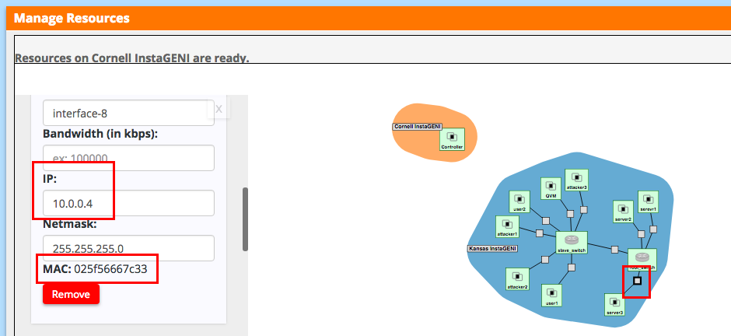
3. Then go back into the root-switch console. Type the command ifconfig | grep $num, replacing $num with the last two characters of the MAC address. It should return the interface number as shown below:  
     
   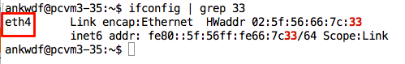
4. Please note that multiple MAC addresses may share the last two characters; If multiple interfaces are returned, select the one that completely matches the MAC address you recorded.
5. Now that you have the interface number, go back into the controller and open the openNetwork-ADAPTS.py file if it is not open already. Navigate to the root_switch variable on line 23 again, and below it will be the port designations based on the IP address. What we’re going to want to do is change the number inside SetPort() to the number of the network interface on the line that matches the IP address that is tied to the MAC address you recorded previously. As you can see in the following picture, I changed the number inside SetPort() to 4 on the line that had the IP address 10.0.0.4:  
   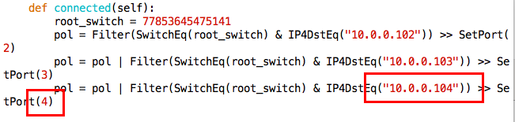
6. Repeat steps 1 through 3 for server2 and server1 as well. Once this has been completed, log into the slave-switch. The steps 1 through 3 above are essentially the same as what we’ll do for this switch, but I’ve included the steps below so that visual examples can be illustrated for the slave-switch portion as well.
7. Go on to the GENI interface again and click the link between user1 and slave-switch. The sidebar will open containing the IP address and MAC address information. Please go down to the Interface to slave-switch section and make a note of the IP address and MAC address. The image below shows where they are located on the page:  
   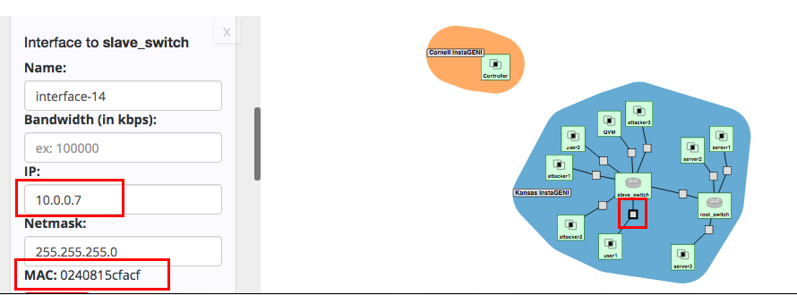
8. After you obtain the IP address and MAC address, go into the slave-switch console and type the command ifconfig | grep $num, replacing $num with the last two characters of the MAC address. It should return the interface number as shown below:  
   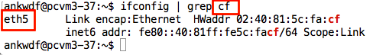
9. Once you obtain the interface number, log back onto the controller and open the openNetwork-ADAPTS.py file if it is not open already. Navigate to the slave_switch_1 variable, and below it will be the port configurations for each server connected to it. Find the line containing the IP address you recorded previously and replace the number inside the SetPort() function to the interface number you obtained from the slave-switch console. In the below example, the IP address was 10.0.0.7 and the MAC address of the server that has this IP address matched the interface eth5. Therefore, the number inside the SetPort() function needed to be changed to 5 as shown below:  
   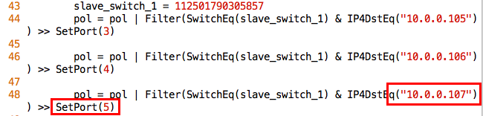
10. Repeat steps 5 through 7 for each server connected to the slave-switch, and then save the openNetwork-ADAPTS.py file on the controller.
11. In root switch, for all the virtual machines connected to slave switch’s SetPort should be set to the root switch port number (check the eth numbers like you did before for other VM’s) to direct the traffic’s to slave switch.

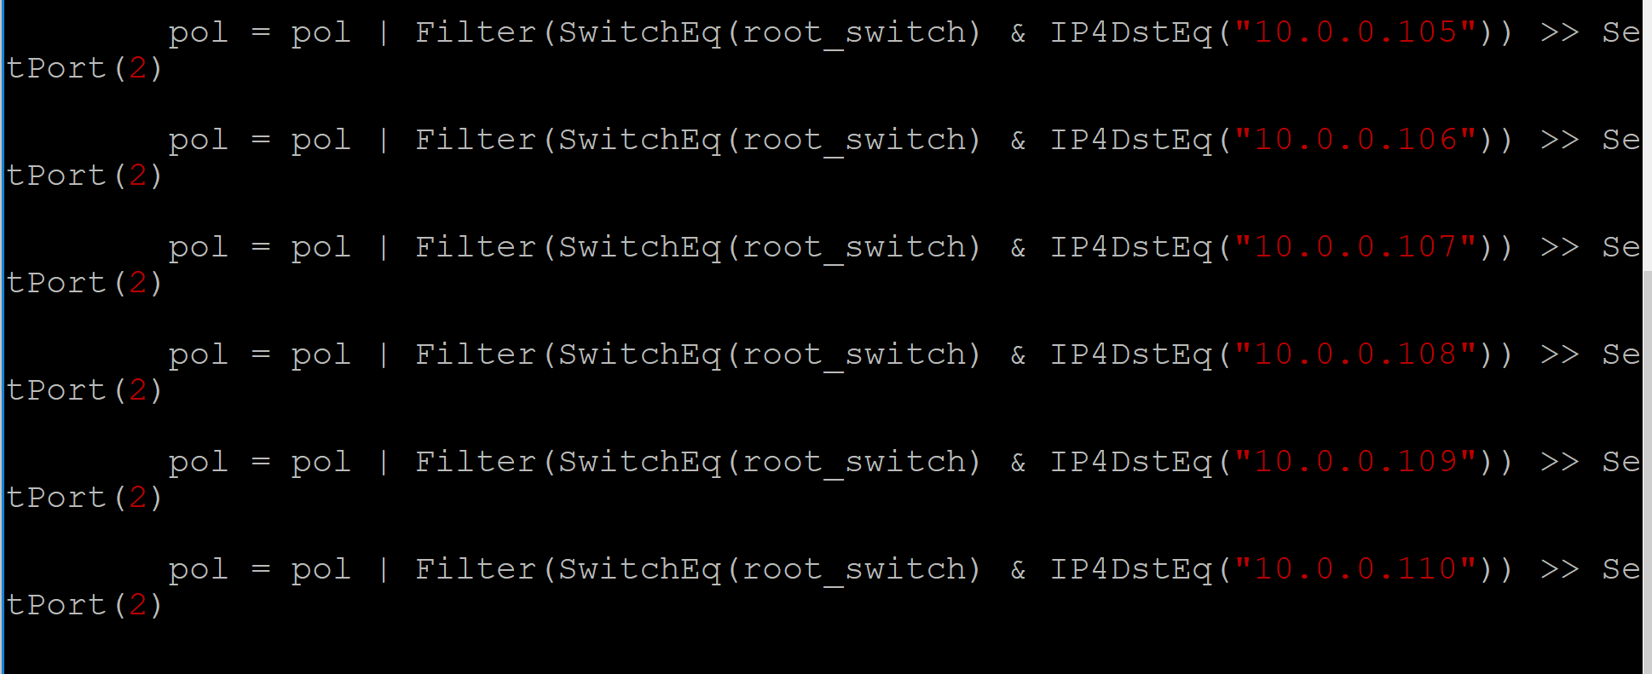

1. In slave switch, for all the servers SetPort should be the port number of the slave switch port number (this need not be same as the root switch, check the eth numbers like you did before for other VM’s) to direct the traffic to root-switch.

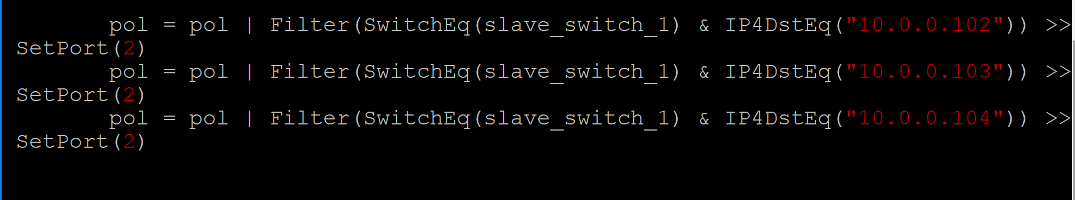

1. After saving it, execute the command python openNetwork-ADAPTS.py to run the file and create the bridge. Ensure you’re in the /var/www/public_html/Dolus_DDos/app/Python directory when you’re executing the file.

|  |
| --- |
| cd /var/www/public_html/Dolus_DDos/app/Python  python openNetwork-ADAPTS.py |

You should see rules table like below.

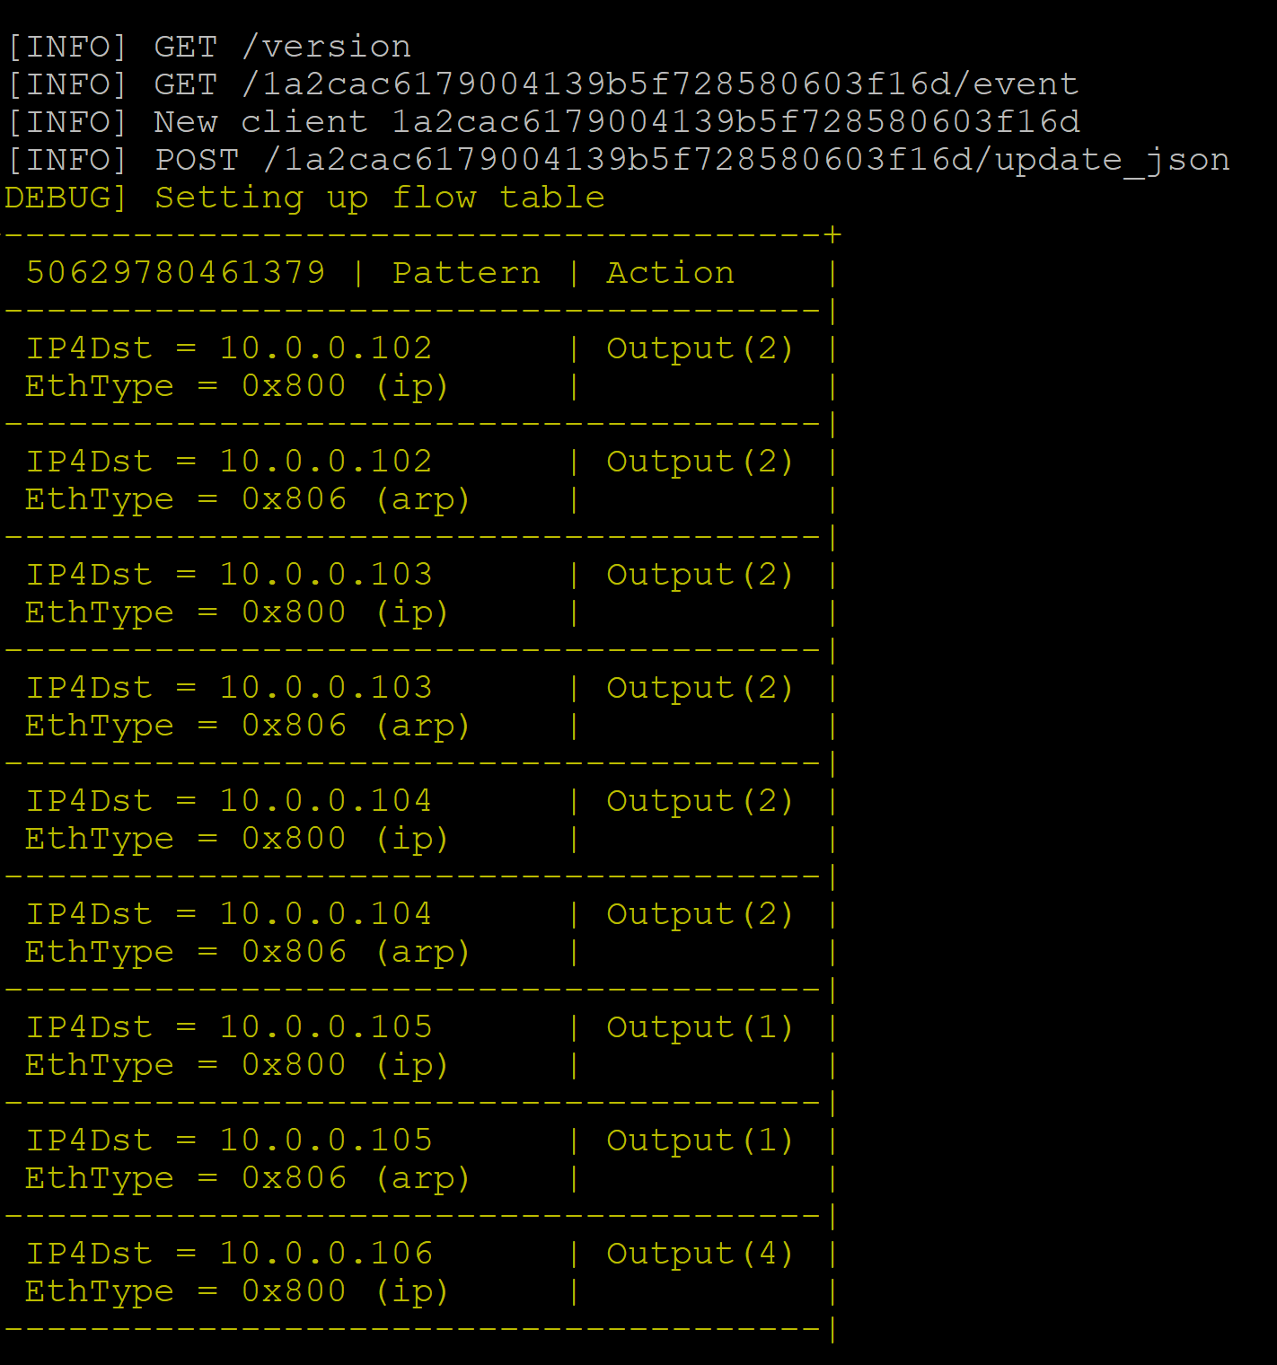

1. Now that the file has been executed, the bridge has been created to allow the servers connected to the root-switch to be able to communicate with the servers connected to the slave-switch. Log into each device connected to the root-switch and ping the devices connected to the slave-switch. The syntax for ping is ping $ip_addr, replacing $ip_addr with the IP address of the device you want to ping. Each ping should succeed, showing that network traffic can be sent between the two switches. Similarly, log into each device connected to the slave-switch and attempt to ping the devices connected to the root-switch. The ping attempts should be successful, and we can now use tshark to capture data and perform the attack using slowhttptest.

**IP address of a VM is the IP address given for Interface to that Virtual Machine.**

1. You should be able to ping one node from another like below

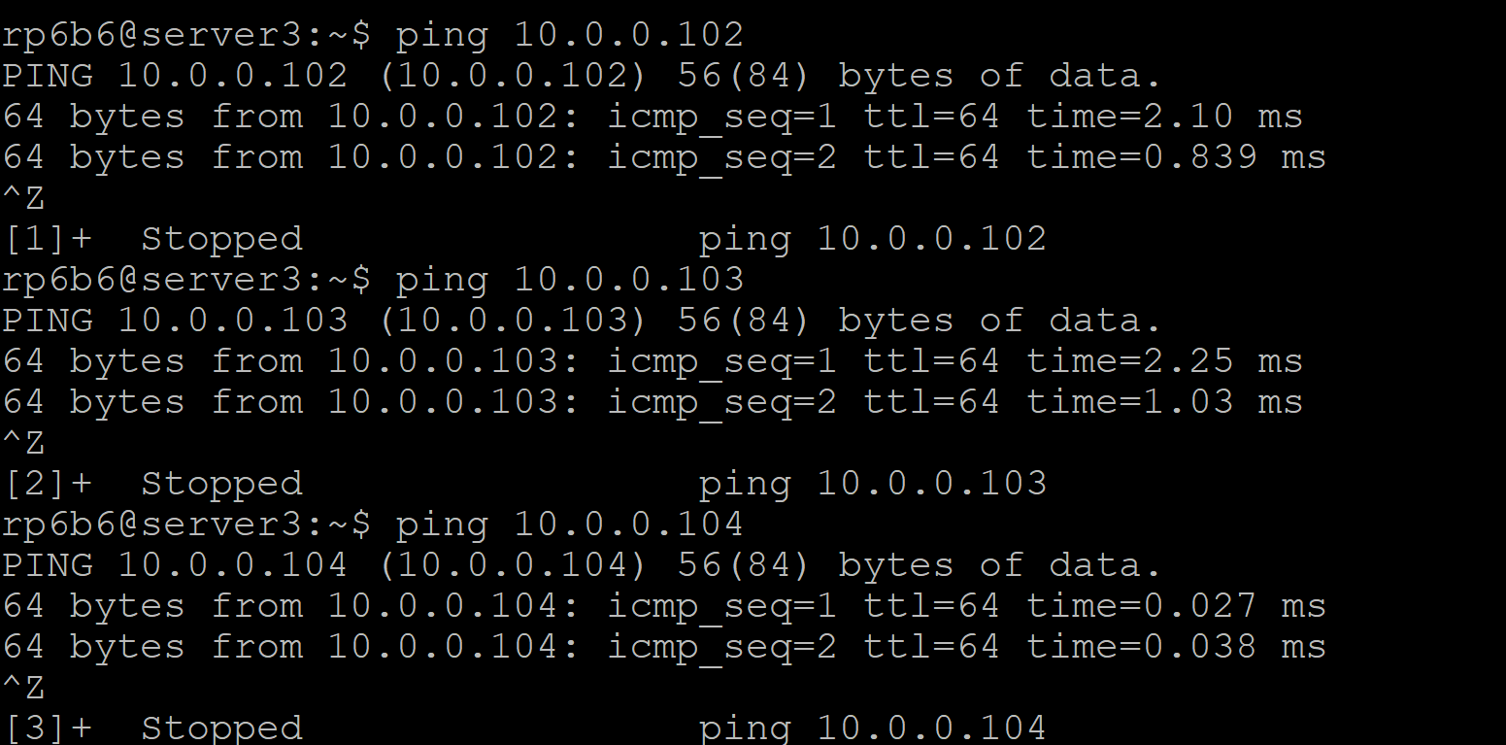

* 1. **Start packet flow capture**  
     **Note: We assume that TA coordinated GENI team about launching a DDoS attack.**

**Please ensure that your bandwidth and packet capture scripts are running when you launch the attack because we need to capture the bandwidth and packet data while the attack occurs.**

First, capture the packet flow on the root switch and slave switches:

* + - 1. Install the following commands on both switches:

**Give mysql-server password as ‘root’**. But we will use controllers global user credentials monty and some_pass.

|  |
| --- |
| *sudo apt-get install -y Tshark*  *sudo apt-get install -y mysql-server*  *sudo apt-get install -y python-mysql.connector*  *sudo apt-get install bwm-ng* |

* + - 1. **Bandwidth Capture**

Open new terminals for both the root switch and slave switch, and execute the following command on both the root switch and slave switch terminals to capture the bandwidth details:

|  |
| --- |
| *rm -f stats.csv*  *bwm-ng -o csv -T sum -F stats.csv* |

* + - 1. **Packet Capture**

And in a different slave switch and root switch Terminals run the following Tshark commands to capture the packet flow.

* **SSH in to root switch console**

|  |
| --- |
| *sudo tshark -i eth2 -i eth3 -i eth4 -T fields -e frame.number -e frame.time_relative -e frame.time_epoch -e frame.protocols -e frame.len -e eth.src -e eth.dst -e eth.type -e ip.proto -e ip.src -e ip.dst -E header=y -E separator=, -E occurrence=f > ~/root-capture.csv* |

* **SSH in to Slave switch console**

|  |
| --- |
| *sudo tshark -i eth2 -i eth3 -i eth4 -i eth5 -i eth6 -i eth7 -T fields -e frame.number -e frame.time_relative -e frame.time_epoch -e frame.protocols -e frame.len -e eth.src -e eth.dst -e eth.type -e ip.proto -e ip.src -e ip.dst -E header=y -E separator=, -E occurrence=f > ~/root-capture.csv* |

* 1. **Launch a DDoS attack**

1. Login to Attacker1 Console via SSH using the GENI interface.

After updating the package lists and installing the slowhttptest package, we can now launch the slowhttptest attack. Please execute the command below, replacing $server1IP with the IP address of server1:

|  |
| --- |
| *sudo apt-get -y update*  *sudo apt-get -y install slowhttptest* *slowhttptest -c 1000 -H -g -o slowhttp -r 200 -t GET -u http://$server1IP/* |

***example:*** *slowhttptest -c 1000 -H -g -o slowhttp -r 200 -t GET -u* 10.0.0.102

***You should see the following output after you launch the attack***

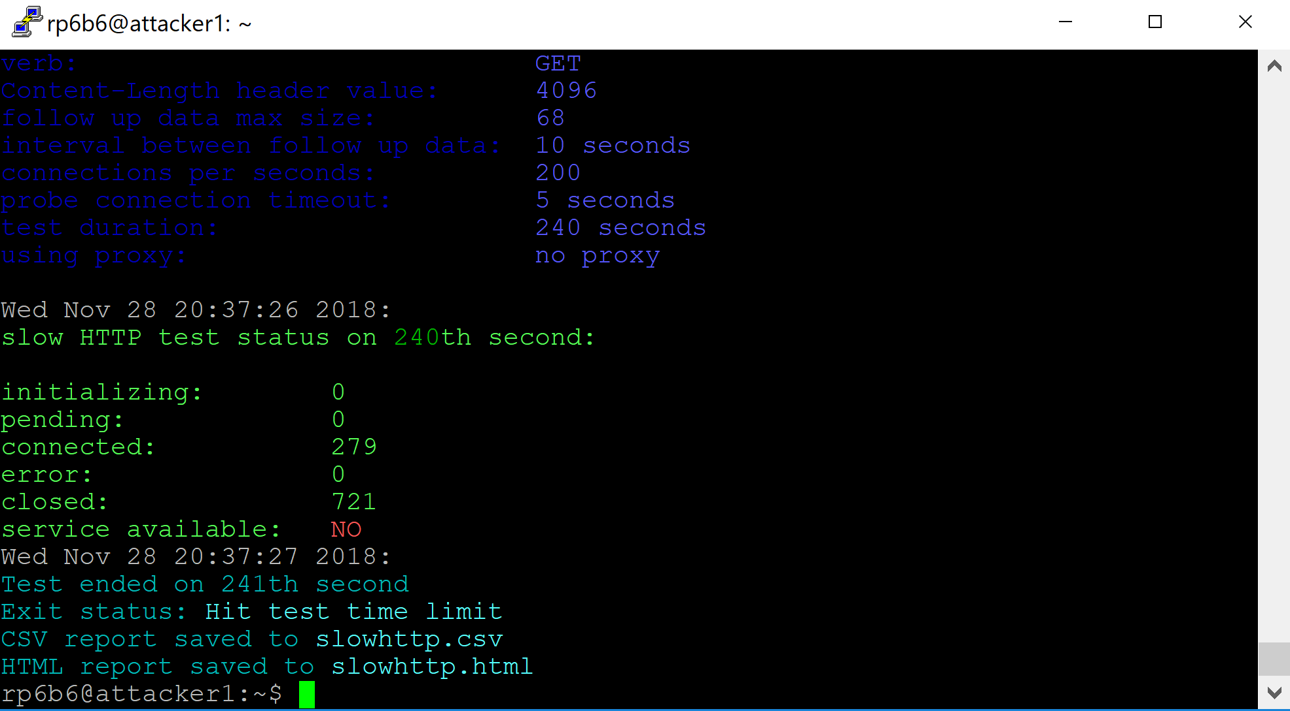

* 1. **Stop the packet/bandwidth capture and store the data**

Press CTRL+Z to suspend the running commands (both packet capture and bandwidth capture script) after the attack is launched and cancel the data transfer from hosts too. Now, we can store the data into tables using the following commands

We need to append the switch_id and trace_id to the root_capture.csv. for that we need to execute the following awk command by replacing switchDPID with your switch DPID and trace_id with the current number of executions. (here trace_id is the nth no of execution, If it’s the first time it should be 1)

Execute the following commands on both slave switch and root switch consoles opened for **packet capture**.

|  |
| --- |
| *awk '{print <switchDPID>,",<trace_id>,", $0}' root-capture.csv > result.csv* |

***Example****: awk '{print 196040413341508,",2,", $0}' root-capture.csv > result.csv*

To store the packet data captured on a switch into the tables execute the following

command by logging into mysql database on switch

|  |
| --- |
| *mysql -h CONTROLLERIP -u YOURUSERNAME -p --local-infile YOURDBNAME;* |

***Example****:* *mysql -h 72.36.65.106 -u monty -p --local-infile test;*

|  |
| --- |
| *use test;*  *LOAD DATA LOCAL INFILE 'result.csv' INTO TABLE test.packet_logs COLUMNS TERMINATED BY ',' IGNORE 1 LINES;* |

Now the captured **Bandwidth data** in first terminals of root switch and slave switch including switch_id is stored in result.csv

|  |
| --- |
| *awk '{print "<Switch_id>;", $0}' stats.csv > outstats.csv* |

***example:*** *awk '{print "196040413341508;", $0}' stats.csv > outstats.csv*

To store the packet data captured on a switch into logs tables execute the following

|  |
| --- |
| *mysql -h CONTROLLERIP -u YOURUSERNAME -p --local-infile YOURDBNAME;* |

***Example****:* *mysql -h 72.36.65.106 -u monty -p --local-infile test;*

|  |
| --- |
| *use test;*  *LOAD DATA LOCAL INFILE 'outstats.csv' INTO TABLE test.logs COLUMNS TERMINATED BY ';' (switch_id, unixtimestamp, port_id, tx_bytes, rx_bytes, total_bytes, tx_packets, rx_packets,total_packets,tx_errors,rx_errors);* |

* 1. **Detecting and Deceiving the attacker using QM**

**Detect an Attack**

1. Now, log on to the controller via SSH and execute the following commands to detect the suspiciousness scores on controller:

|  |
| --- |
| *cd /var/www/public_html/Dolus_DDos*  *sudo apt-get install python-mysqldb*  *sudo pip install MySQL-python python app/Python/main.py* |

**If you get any error on no module named MySQLdb, try installing Mysqldb for python.** **If you face any issues while executing main.py, you might have to delete the data from your suspiciousness_scores table and reexecute main.py(as trace_id’s will be different if you execute without deleting the data from suspiciousness_scores and you might get unexpected results)**   
The main.py Python script calls two Python scripts to calculate the suspiciousness scores for each device.

**Redirect the attacker traffic**

1. At this point, we’re going to deceive the attacker. On the controller, execute the following commands to change the directory to the one containing the Python scripts and edit the openNetwork-ADAPTS.py file:

|  |
| --- |
| *cd /var/www/public_html/Dolus_DDos/app/Python sudo nano openNetwork-ADAPTS.py* |

Navigate to line 64 and change the IP address inside of SetIP4Dst(), ensuring that the IP address you change it to is the IP address of the QVM server.

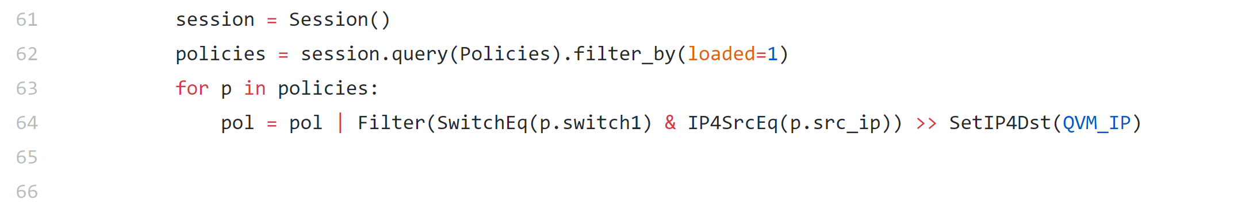

Then, save and quit (in nano, the syntax to save is Ctrl+O, then to quit is Ctrl+X). Changing the line above allows the script to reset the network with a custom policy that redirects Attacker Traffic to the QVM. Attacker won’t be able to ping any other device as we set attacker destination to QVM.

**You can find the IP address like below. IP address of a VM is the IP address given for Interface to that Virtual Machine.**

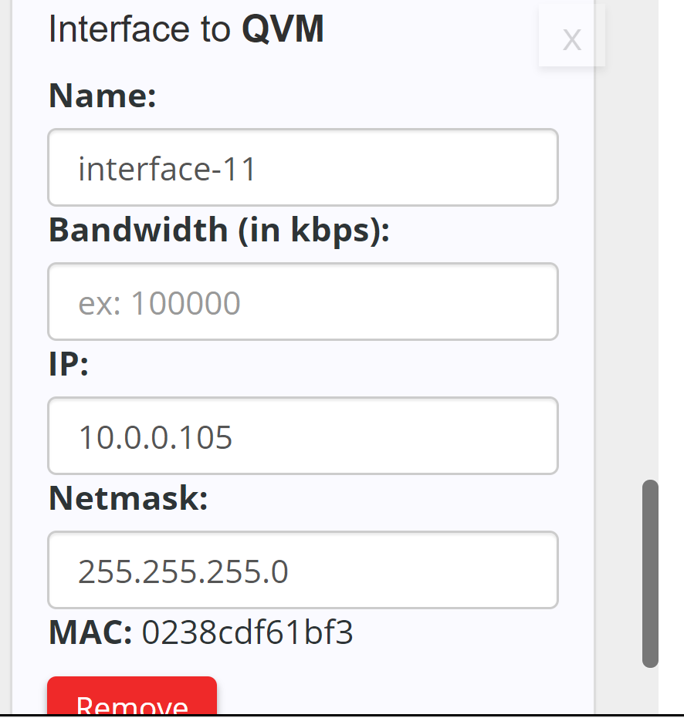

1. Run below python script to redirect the attacker to QVM.

|  |
| --- |
| *python openNetwork-ADAPTS.py* |

Whenever an attack is detected, A policy will be created to redirect the attacker to qvm. You can see the new Policy created in Policy table for the srcIP. Take a screenshot of the new Policy record created in policy table.

You should see the following flow on your attacker console.

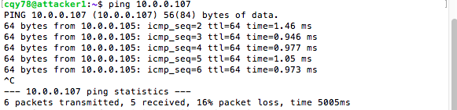

**Deceive the attacker**

1. Run the following pretense.py on your QVM Console(You can find this file in Dolus-Lab 2 modules), this python script uses Scapy to send fake responses to attacker to deceive him

|  |
| --- |
| *sudo apt-get update*  *sudo apt-get install scapy* |

Open you pretense.py and edit your attackerIP and then execute pretense.py

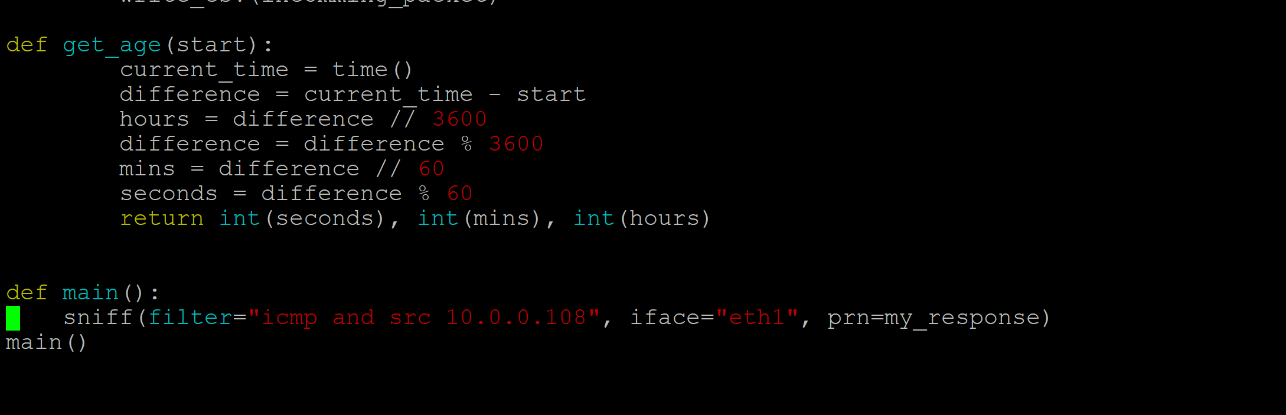

And then execute pretense.py

|  |
| --- |
| *Sudo python pretense.py* |

When you execute pretense.py you will see the following output in QVM console

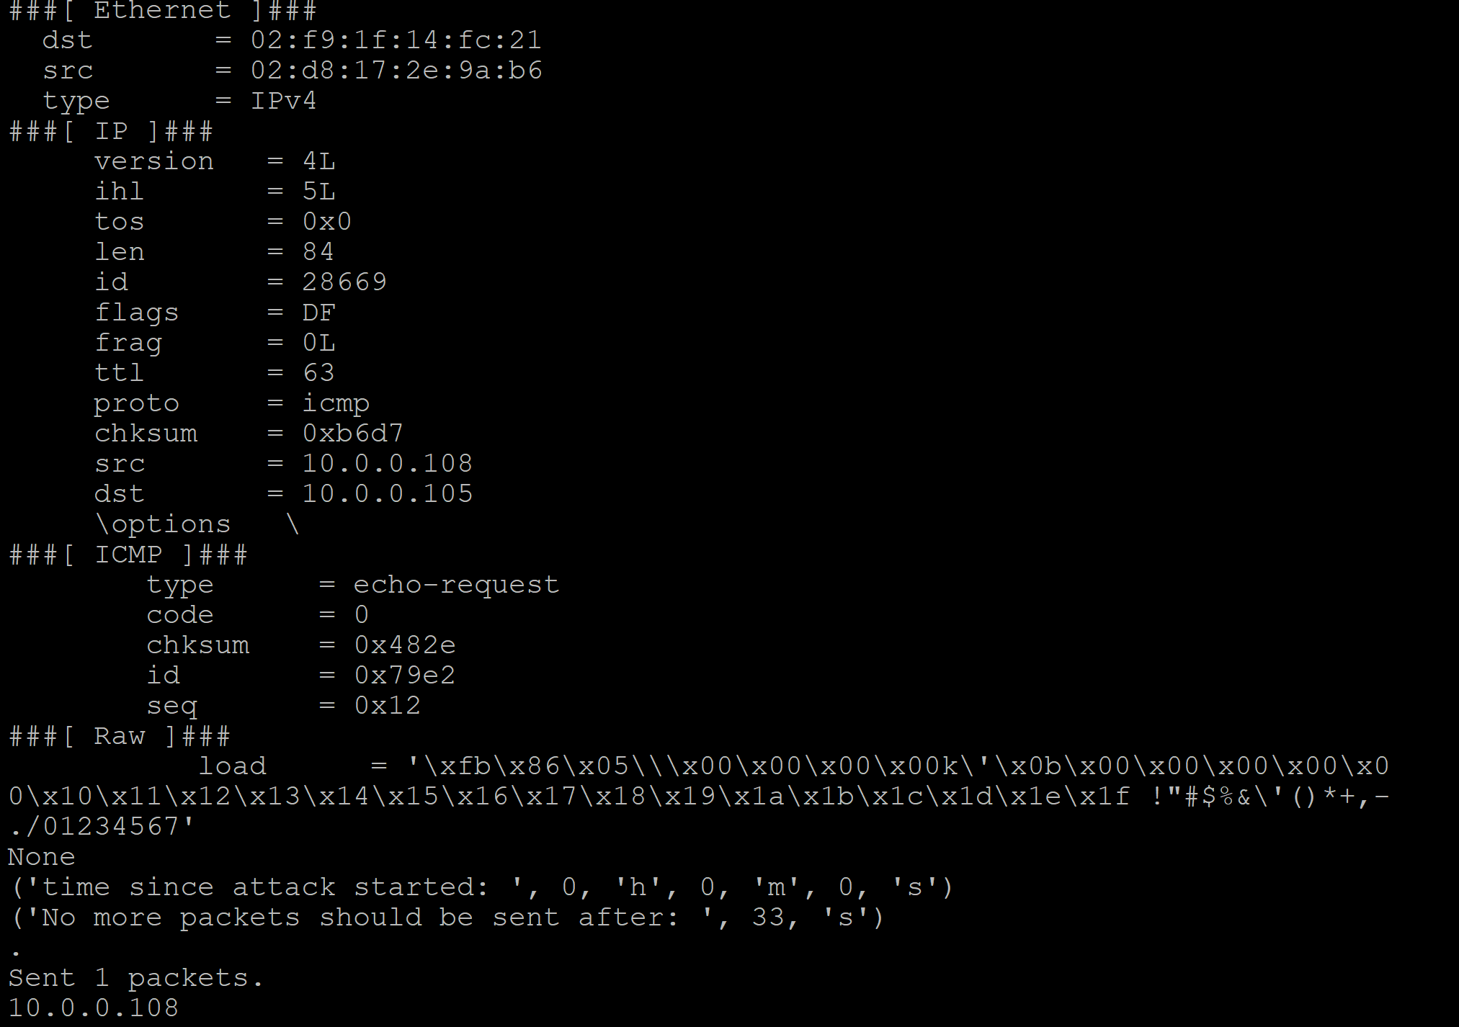

|  |
| --- |
| **Notes regarding the screen command:** **To use screen to run the scripts while being logged off, you first need to install it. Run the command** sudo apt-get -y install screen on the server you want to run the script on. After installing screen, execute the command screen. At this point, anything you do will be in a shell that can be saved for later. Now, run the command to execute the script, and while it’s executing, hit Ctrl + A followed by Ctrl + D. You will be returned to your regular shell, and you can run the command screen –r to return to the saved shell. As long as the server is not powered off, the script will continue to execute in the background. |

* 1. **Observing the attacker, user and server information in the website.**

**(Don’t panic if your graphs little different, it might change according to the data incoming or connections made)**

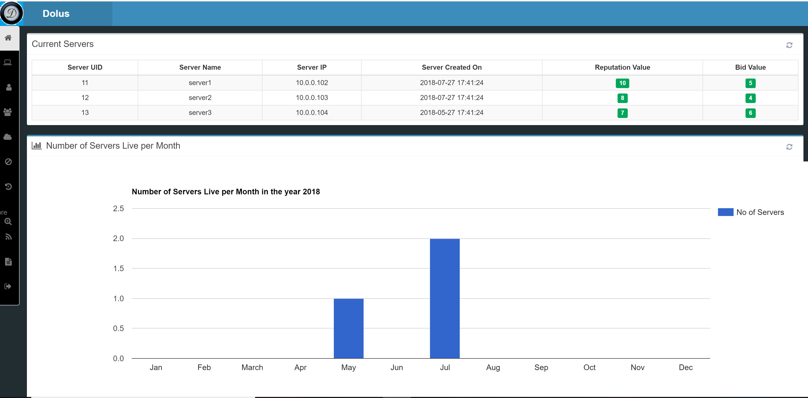

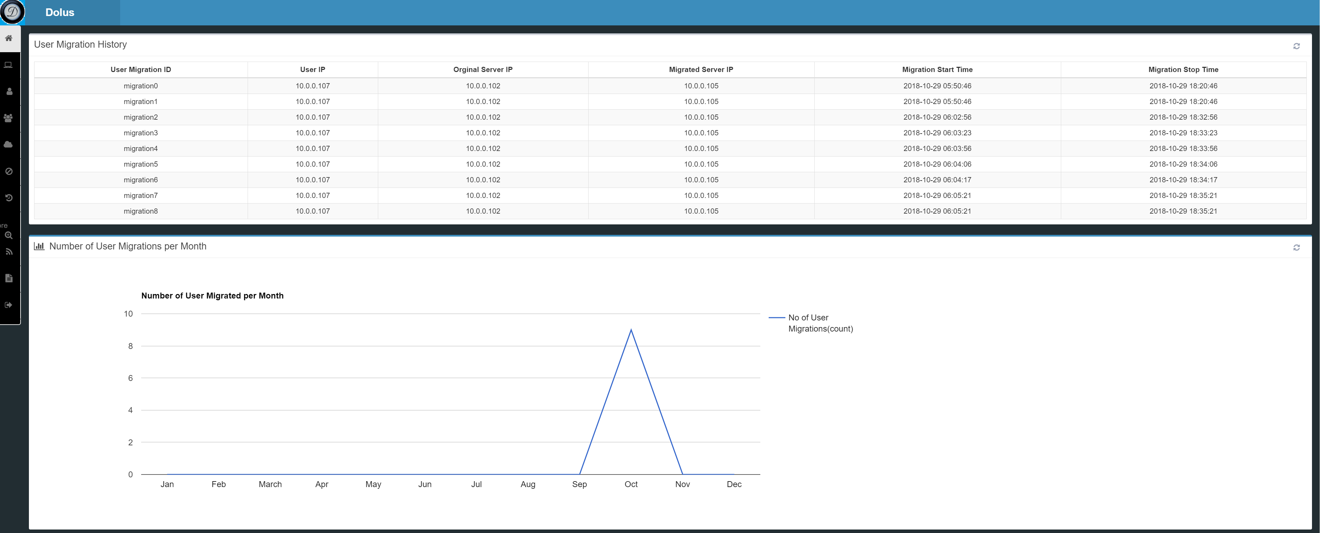

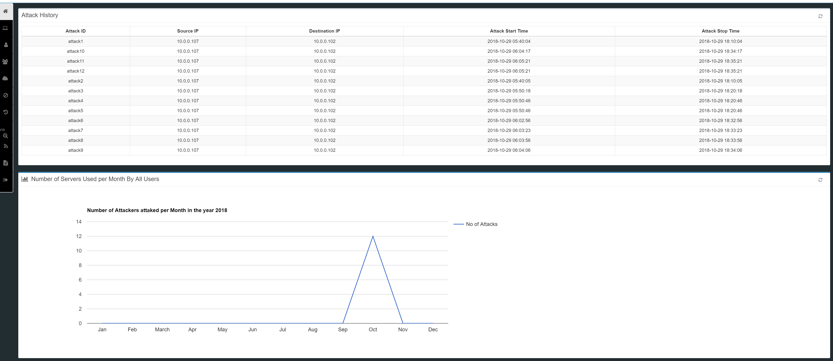

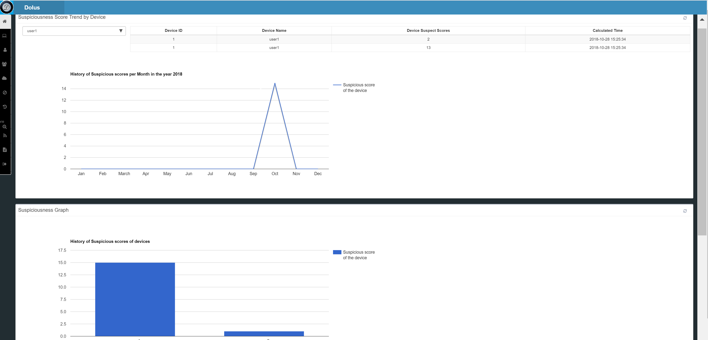

1. **What needs to be turned in for Grading?**

**Provide your controllerIP, User name and password for grading purposes**

* + 1. What is Distributed Denial of service attacks? Suppose a web application is hosted on Server1 and several users are trying to access the Web application. Explain briefly the following scenarios?

1. What will happen when many users try to refresh the web browser in which they are accessing the webpage over and over on different computers at once. Explain me briefly what type of DDoS attack is possible in this scenario and a possible solution in your own words?
2. A User broadcasted a huge volume of TCP, UDP and ICPM  packets with the intended victim's [spoofed](https://en.wikipedia.org/wiki/IP_address_spoofing) source IP to a [computer network](https://en.wikipedia.org/wiki/Computer_network) using an IP [broadcast address](https://en.wikipedia.org/wiki/Broadcast_address). What can happen when most devices on this network respond to this by sending a reply to the source IP address. Give a possible solution in your own words?
   * 1. What is an Memcached DDoS attack? Explain in detail, how does the code repository GitHub was [taken off air](https://www.theregister.co.uk/2018/03/01/github_ddos_biggest_ever/) in a 1.3Tbps denial of service attack ? What are the implications to the organization running memcache servers and what can be the amplification of the attack? What is the cost and expertise needed to setup a cloud configuration that can mitigate the memcache attack?
     2. Describe the methodology used in detecting an attacker in step 3.8 and 3.9
     3. Take screenshots of the graphs of Network flow, bandwidth flow and switches from AdminUI and describe the network abnormality in your own words.
     4. Explain in detail, what surprised you about the Dyn.Inc Attack? What caused the attack Human error, technology convergence or Infrastructure? What’s new that we can learn to defend DDoS attacks at this scale? Write Scapy commands to recreate the attack in GENI testbed and Frenetic commands to apply pretense. What’s preventing the attacker from going to the new URL which legitimate users are going?
     5. What are NETKAT Policies and how can we implement policies for the security of the network? Suppose all the traffic to ServerS1 through root_switch is directed to port 2 as given by the following command:

*pol = Filter (SwitchEq(root_switch) & IP4DstEq ("10.10.2.2")) >> SetPort(3)*

Similarly, write commands to redirect the attacker traffic to a Quarantine machine and block the traffic from attacker to server1 using NETKAT Policies where IP address of QVM is 10.10.5.2 and the attacker IP address is 10.10.10.1.

* + 1. How would you modify NetKat policies to include an additional slave switch connected to the root switch? How would the policy change to allow data to transfer between a device on the first slave switch and a device on the second slave switch?